The Centre Burton Hill Bourton-on-the-water
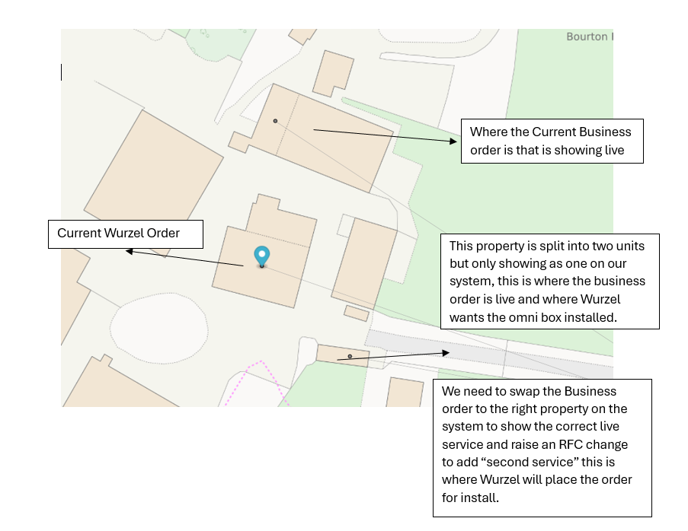
Internally we need to swap the orders so they reflect the correct addresses and then create an RFC (Request for Change) so that a second service ID can be created to be installed. Wurzel can then complete works to bring cable from where the 2nd NTE will be installed to where they want the service live.
We will not be able to process an RFC for at least 2 weeks due to a system upgrade.
Once the RFC has been raised and completed, Wurzel will need to cancel the current order on the Centre and place the new order on Unit 1 (2nd Service). Installation can then be completed, and Wurzel can complete works from 2nd NTE to connect the building we are unable to connect.
This is the proposal, Are Wurzel happy to go down this route to get this Service live?

