Cardwell House
Hook Norton Road, Great Rollright, Chipping Norton, Oxfordshire, OX7 5SB
What3Words: lizards.perfectly.blitz

Directions

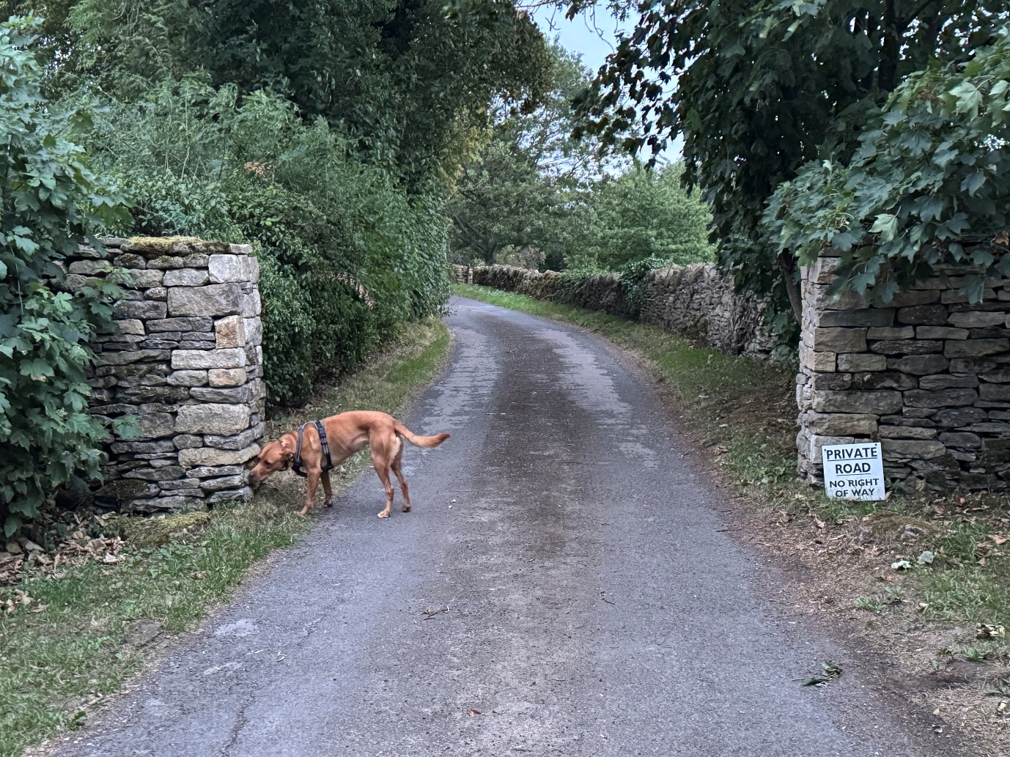

Please use the postcode OX7 5SB on your satnav.

The Satnav will direct you off Hook Norton Road and onto a lane. As you enter the lane, look for a small sign on ground level at the base of a stone wall on your right reading "Private Road, No Right of Way ".

Cardwell House is the very last house at the end of this lane on the right.

- Follow the lane past Duck End.

- Drive under the small canopy of trees.

- Pass the entrances to Cardwell Bungalow and The Granary (both on your right).

- At the end of the lane, you will see a set of iron gates directly ahead.

- Turn right immediately in front of the gates to arrive at the house (you do not need to go through any gates).

