Wurzel Ltd
Unit 5 The Millhouse, Elmsfield Industrial Estate
Worcester Road
Chipping Norton
Oxfordshire
OX7 5XL

Our Ref: WMC027645 21/09/2026

Thank you for selecting Grundon Waste Management Ltd. We appreciate that you have a range of suppliers to choose from and we’re confident you won’t regret your decision. Our customer base includes thousands of organisations very like your own, the majority of which have been with us for many years.

Further to your recent request, we are pleased to confirm that we have opened a credit account for your organisation with a credit limit of £300. This will be reviewed after your first three months’ trading and may be revised if necessary. Please note that our payment terms are strictly nett monthly.

Your account number is WURZ001/1. Please quote this number in all correspondence with us. Your account will be serviced by our depot at Banbury
In the event of any queries relating to our service, please contact the Customer Services team at sales.banbury@grundon.com or by telephone on 01295 253611. For invoice-related queries, please email invoicing@grundon.com.
If you have specified more than one collection address for your account, we would be grateful if you would copy the enclosed contact details to each site.
We enclose a customer welcome pack for your information and assistance and look forward to being of service.
Yours faithfully
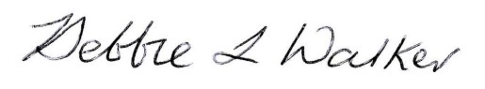

Debbie Walker
New Accounts Administrator

